What the DAG should look like:

iRCT Output:

Outcome COVID:

* Relation value for ED_Visit: 0.0048169494095434235
* Relation value for Dyspnea: 0.7165481689737879
* Relation value for COPD: -0.009157305841275602

Outcome Dyspnea:

* Relation value for ED_Visit: 0.11081961503383671
* Relation value for COPD: 0.051536310185333466

Outcome ED_Visit:

* Relation value for COPD: -0.0025062154829457403

FCI Output:

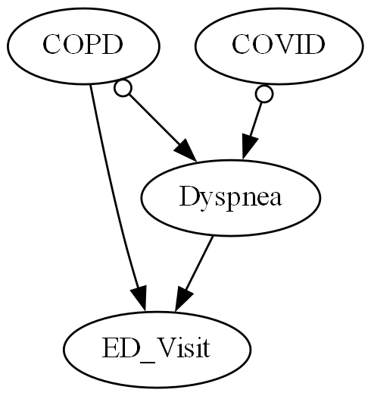

GES Output:

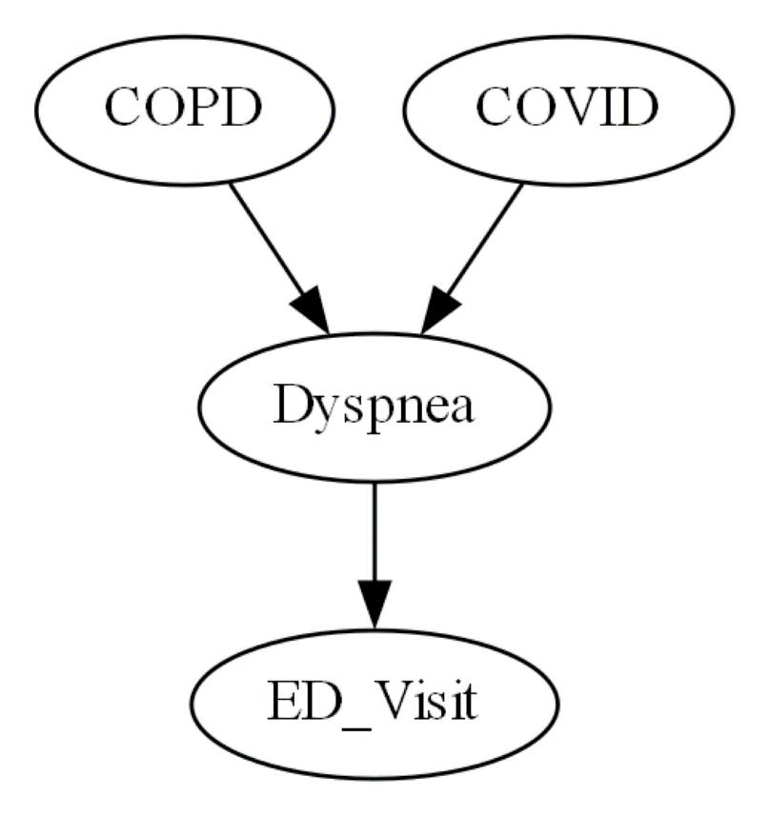

PC Output:

